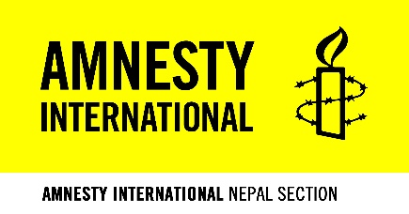

Photo

Amnesty Marga, Basantanagar
P.O. Box 135, Balaju, Kathmandu, Nepal
Phone: +9779851336996, 01 4964706 or 4965431
info@amnestynepal.org
www.amnestynepal.org
Membership Application Form (Youth/Non-Youth)

I would like to apply for the Membership of Amnesty International Nepal. I hereby agree to accept, be bound with, and abide by present and future rules and regulations of the organization.

Name (In Capital Letters) ………………………….… नाम (देवनागरीमा)…………………………..
Date of Birth(DD/MM/YY): AD …... /…../ 20…. BS ..... /…. / 20….
Occupation ………………………………………… Education……………………..……………
Associated School/College/Office ……………………………………………………………………..…….…..
Telephone/ Mobile …………………………………. Gender……………………………………..
E-mail ………………………………………….…. Citizenship no. ………………..……………
Religion………………………………………….… Ethnicity………………………………...…

Permanent Address
Province ……………………………….…. District…………………………………......
Rural municipality/Municipality/Sub-Metropolitan City/Metropolitan City ………………………….…...…… City/Town……………………..…………… Tole ……………..………...… Ward No. ….
Postal Address
[If you prefer to give the address of your office as your postal address here, please write the full address of your office (including phone numbers) in the box below.]

Province ……………………………….…. District…………………………………......
Rural municipality/Municipality/Sub-Metropolitan City/Metropolitan City ………………………….…...…… City/Town……………………..…………… Tole ……………..………... Ward No. …...
Telephone ………………………………… P.O. Box …………………………………

Applicants' Signature ………………………………….. Date : … … … … … …

Recommended by (either coordinator or vice coordinator of Group/Youth Network)
Name ………………………………………….. Designation ……………………………...
Group/YN.……………………………………….
Signature ………………………………………. Group stamp ……………………………..

Note: The personal data and identity document provided will be used for our internal purposes only and will not be divulged to any third party without your consent.

The applicant must be at least 16 years of age.
The applicant's age must be between 16 and 25 years for Youth Membership.

